# Transformer Design

Flyback converter isolates a primary side and a secondary side with a transformer. Transformer can be used to step up or down an input voltage according to turns ratio. Besides, input-output relation is the same as buck boost converter. Input-output relation is shown in Equation (1).

|  |  |  |
| --- | --- | --- |
|  |  | (1) |

Transformer is mainly used for the applications transmitting energy without storage. However, transformer of flyback converter stores an energy, and then passes it to secondary side, which is the reason for why flyback transformer is also called as coupled inductor. Hence, considerations for energy stored, saturation current, inductance are important for transformer design. The design of transformer is started with application information given in the datasheet.

Table 1 shows some system level information and controller requirements having an impact on the transformer design.

Table 1 Parameters for the transformer design

|  |  |  |
| --- | --- | --- |
| **Description** | **Symbol** | **Value** |
| Input voltage range | Vin,min - Vin,max | 220V – 400V |
| Output voltage | Vo | 12V |
| Max. output power | Pout | 100W |
| Max. switching frequency | fs | 140kHz |
| Min. Switch off time* | tOFF(MIN) | 800ns |
| Min. Switch on time* | tON(MIN) | 300ns |
| Backup time* | tBU | 50μs |

*\* These parameters will be explained in detail while calculating their limitations on primary inductance.*

Application information given in the datasheet determines the minumum and maximum limits for the primary, magnetizing, inductance due to parameters given in Table 1 such as tOFF(MIN), tON(MIN) and tBU. Before finding the limitations, the peak of the primary current should be determined according to working principle of controller and the delivered maximum output power. While the mininum current limit of the controller affects the limitations of primary inductance due to tOFF(MIN) and tON(MIN), the maximum output power has to be satisfied according to magnetic energy storage shown in Equation (2).

|  |  |  |
| --- | --- | --- |
|  |  | (2) |

The maximum peak current in primary side can be found from the desired output power. Since the peak current is observed at maximum power and the controller has boundary mode control, the peak current can be calculated as seen in Equation (3). Efficiency is taken as %80 as a safety margin due to practical considerations.

|  |  |  |
| --- | --- | --- |
|  |  | (3) |

## Limitations of Primary Inductance

### tOFF(MIN) – Minimum Switch Off Time

The feedback of the output voltage is given through the tertiary winding. The nonzero voltage between the tertiary winding is created when the secondary current flows. The required minimum time to sample voltage by the sample-and-hold error amplifier is 800ns. “*In order to ensure proper sampling, the secondary winding needs to conduct current for at least 800ns*.” [Datasheet Magnetizing Inductance Requirement Pg:14] The limitation due to tOFF(MIN) is given in Equation (4).

|  |  |  |
| --- | --- | --- |
|  |  | (4) |

### tON(MIN) – Minimum Switch Off Time

The controller has a minimum switch on time for the sake of blanking initial switch turn-on current spike. The current, ISW(MIN), should not be reached for tON(MIN), which creates restriction on the selection of flyback transformer in terms of magnetizing inductance. The limitation due to switch on time is determined in Equation (5).

|  |  |  |
| --- | --- | --- |
|  |  | (5) |

### Power Storage Capability of the Transformer

Equation (2) shows the magnetic energy stored in a inductor for a given current and inductance. Since the flyback transformer stores magnetic energy due to working principle of flyback converter, the inductance of transformer should be able to store sufficient power. Equation (6) shows the limitation of the inductance due to magnetic energy storage.

|  |  |  |
| --- | --- | --- |
|  |  | (6) |

### Backup Time

Backup timer is stimulated to avoid low output voltage levels. Backup timer turns the primary switch on unless the secondary side diode turns off. This features restricts the inductance value with maximum limit. Limitation of inductance of flyback transformer due to backup time can be seen in Equation (7).

|  |  |  |
| --- | --- | --- |
|  |  | (7) |

## Determination of Turns Ratio

The output voltage is lower than the input voltage level. Transformer should step down the input voltage for reasonable values so that sensitivity of duty cycle should not be high, i.e. duty cycle below %10 is problem for controllers. Therefore, the turns ratio should be high as much as possible in order to keep duty cycle in a range between %50 and %20.

Turns ratio has also impact on breakdown voltage of semiconductors. Table 2 shows maximum terminal voltages of the primary switch and the secondary diode. The turns ratio has reverse effect on the semiconductors. While turns ratio, N, increases reverse voltage of the primary switch, it reduces reverse voltage of the secondary diode.

Table 2 Relation between turns ratio and reverse voltage of the semiconductors

|  |  |
| --- | --- |
| **Semiconductor** | **General Formulation for Reverse Voltage** |
| Primary switch | VDS = Vin + N(Vo + VF) + VLeakage |
| Secondary diode | VR = (Vin/N) + (Vo + VF) |

The turns ratio is selected as 8, which keep the duty cycle between %20 and %30. Also this selection is can be optimized value in terms of reverse voltage of semiconductors and duty cycle. The increase in reverse voltages results in increase in switching losses and decrese in safety margin of devices. Duty cycle of the flyback converter in a range of input voltage is shown in Figure 1.

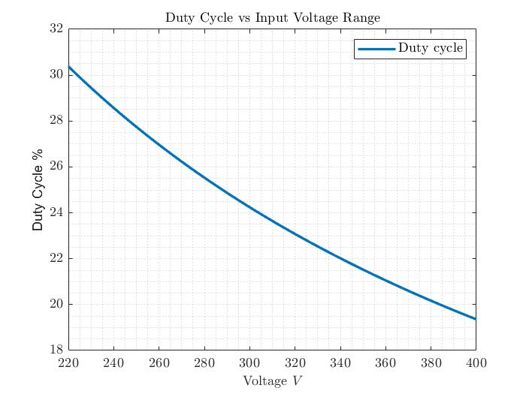

Figure 1 Duty cycle vs input voltage range for 8 turns ratio, N

## Determination of the Primary Inductance

In the part 1.1 , 0.16mH and 1.08mH are founded as minimum and maximum limitations, respectively. The value between the limits may probably work. However, safety margin for each limit should be determined to eliminate unexpected practical issues. The safety region for each limit can be taken as %25 of limiting value above and below for minimum and maximum limits, respectively. Hence, the primary inductance value should be between 0.2mH and 0.81mH.

The boundary mode control requires variable switching frequency according to the load. When the primary switch is on, the inductor current starts from the zero. Therefore, the frequency relation between frequency and inductance for the same input voltage and output voltage is obvious, which is shown in Equation (8). Since duty cycle and turns ratio is constant, switching frequency and primary inductance are inversely proportional for the same amount of inductor current ripple. The inductor current ripple is determined according to output power.

|  |  |  |
| --- | --- | --- |
|  |  | (8) |

Transition to DCM occurs as the load decreases. Duty cycle calculation in DCM can be seen in Equation (9). Both calculation are the same except the Pout, Vo, and R relation in Equation (9).

|  |  |  |
| --- | --- | --- |
|  |  | (9) |

Supply of the input power occurs during the on time of primary switch. Therefore, the current ripple of the inductor is directly related with the delivered power. Equation (10) shows the inductor current ripple calculation in DCM, which shows that Lm and fs are also inversely proportional in DCM.

|  |  |  |
| --- | --- | --- |
|  |  | (10) |

According to analysis of the relation between Lm and fs, increase in Lm results in low switching frequency, hence, low switching loss. On the other hand, boundary mode and DCM eliminates turn-on loss of the primary switch and reverse recovery of the secondary diode. Even if the increase in Lm can be beneficial for switching losses, the trade off due to increase in Lm is increase in size of flyback transformer and increase in windings, which causes more copper and core losses. The question that there is a relation between copper, core losses and frequency. Actually, this type of relations are the signs of need in optimization.

After considering iterative relation between Lm and fs, the Lm, primary inductance, is chosen as 0.4mH.

## Core Selection

Core selection is based on shape of a core, size of a core and magnetic characteristics of a core. First, selection based on magnetic characteristics of a core is analyzed.

### Magnetic Characteristics of Core

General approach for the selection of core type is divided into two for flyback transformer; distrubuted air-gap powder cores and gapped ferrite cores. Both type of cores have advantages. For example, ferrite cores provides a core with more permeability. On the other, distributed air-gap powder cores may have less core loss compared to gapped ferrite cores.

Distributed air-gap powder core is selected based on magnetic characteristrics, which can stimulates an efficiency, winding area and mechanical robustness.

Powder cores are classifed. This classifications are mainly based on core loss, maximum flux density, permeability, and cost, which can be seen in Figure 2 taken from the Magnetics. Kool Mu is selected due to optimal permeability and core loss values. Besides, Kool Mu is preferred due to relative low prices.

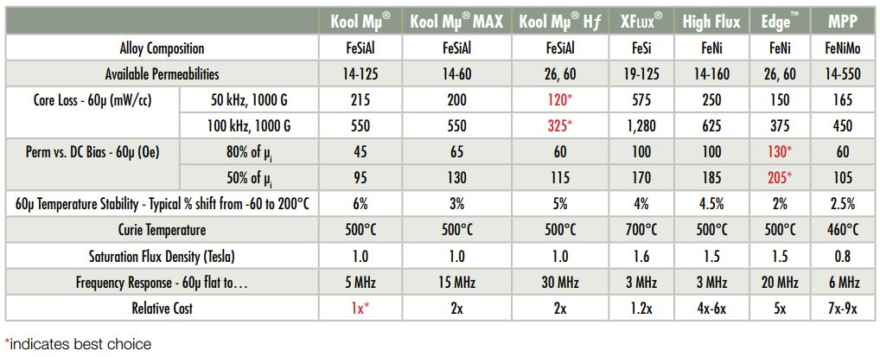

Figure 2 Classification of powder cores [[Magnetics Alıntı](https://www.mag-inc.com/Products/Powder-Cores)]

### Shape of Core

Common preferance for flyback transformers is toroidal shape. The copper loss can be decreased with both toroidal shape and E shape according to the current stiuation. While toroidal shapes have permeability between 14μ-125μ, E shapes have maximum 90μ relative permeability. However, E shapes have relativel higher Ae, area. Also, the window area may be higher in toroids. Hence, toroidal shape is selected.

### Size of Core

Size of core will be determined from available manufactured cores. Cores are researched on [Magnetics](https://www.mag-inc.com/). Selected cores are tested whether they satisfy limitations due to inductance, flux density, saturation current, fill factor. The constrıcted GUI on Matlab is used to test cores. Constructed GUI can be seen in Figure 3.

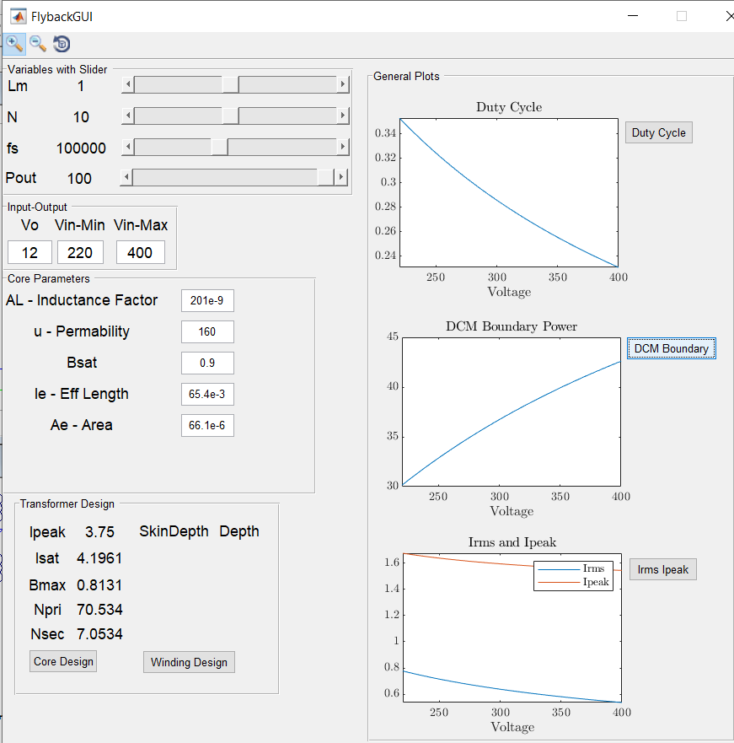

Figure 3 The constructed GUI on Matlab for flyback converter design

Peak current value of the primary side is calculated ISW(MAX) that equals to 3.75A with safety margin. Safety margin is determined according to %80 efficiency of converter. The safety margin for saturation current of a core can be taken as %10, since the efficieny creates a sufficient safe region. Hence, minimum saturation current is 4.1A.

Kool Mu cores have 10,500 Gauss saturation level, which is approximately equal to 1 Tesla. Since the saturation current and created maximum flux density are proportional to each other, saturation can be checked from both created maximum flux density and peak current of the primary side.

Copper losses are also important due to AC resistance and number of windings. The optimization for copper losses based on core selection can be stimulated with selection of cores with high inductance factor, AL.

Table 3 shows the comparison of different cores. Table xxx shows the cores are in order from high volume to low volume. Core 3 is the most suitable one for required saturation limits. Hence, core 3 is selected. Inductance factor would be more to decrease windings but there is no available Kool Mu core.

Table 3 Comparison Kool Mu cores in different sizes and inductance factors

|  |  |  |  |
| --- | --- | --- | --- |
| **Parameters** | **Core 1**  **930** | **Core 2**  **350** | **Core 3**  **310** |
| **Bsat (Tesla)** | 0.9 | 0.9 | 0.9 |
| **μ - Permeability** | 125 | 125 | 125 |
| **AL – Inductance factor(nH/T^2)** | 157 | 105 | 90 |
| **Le – eff length (mm)** | 63.5 | 58.8 | 56.7 |
| **Ae – Area (mm2)** | 65.4 | 38.8 | 31.7 |
| **Isat (A)** | 7.42 | 5.4 | 4.76 |
| **Bmax (Tesla)** | 0.47 | 0.62 | 0.69 |
| **Np (Turns)** | 50.5 | 61.7 | 66.7 |
| **Ns and Nthird (Turns)** | 6.3 | 7.7 | 8.3 |

## Winding and Fill Factor